LCD With No Blocking Function

Note:-
- Each Over Flow Flag Is Considered as 1_ms For Simplicity
- Both Stage And Counter Variables are Global Static Variables

- Timer_0_OVF
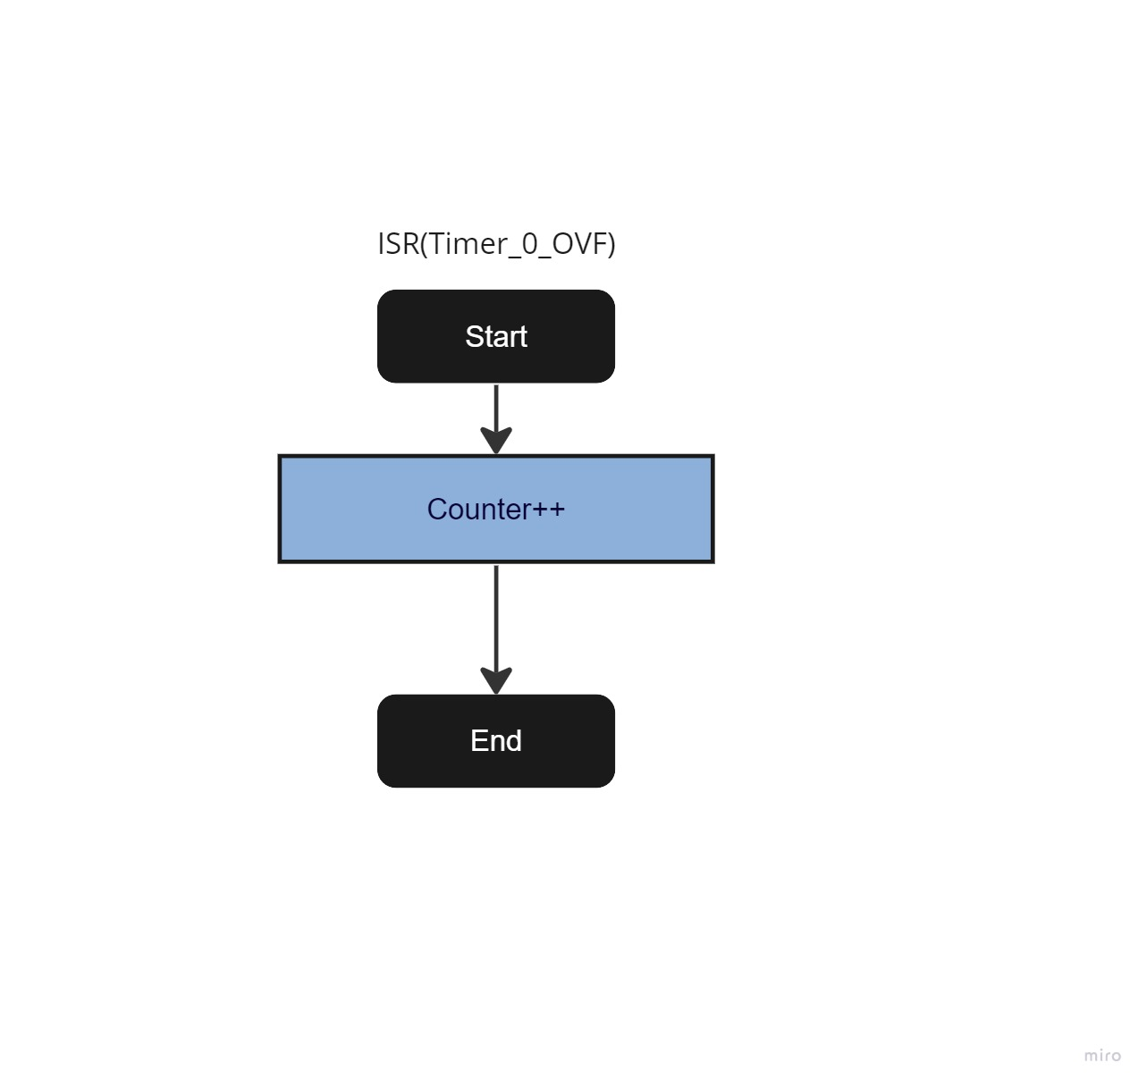

- LCD_Init:-
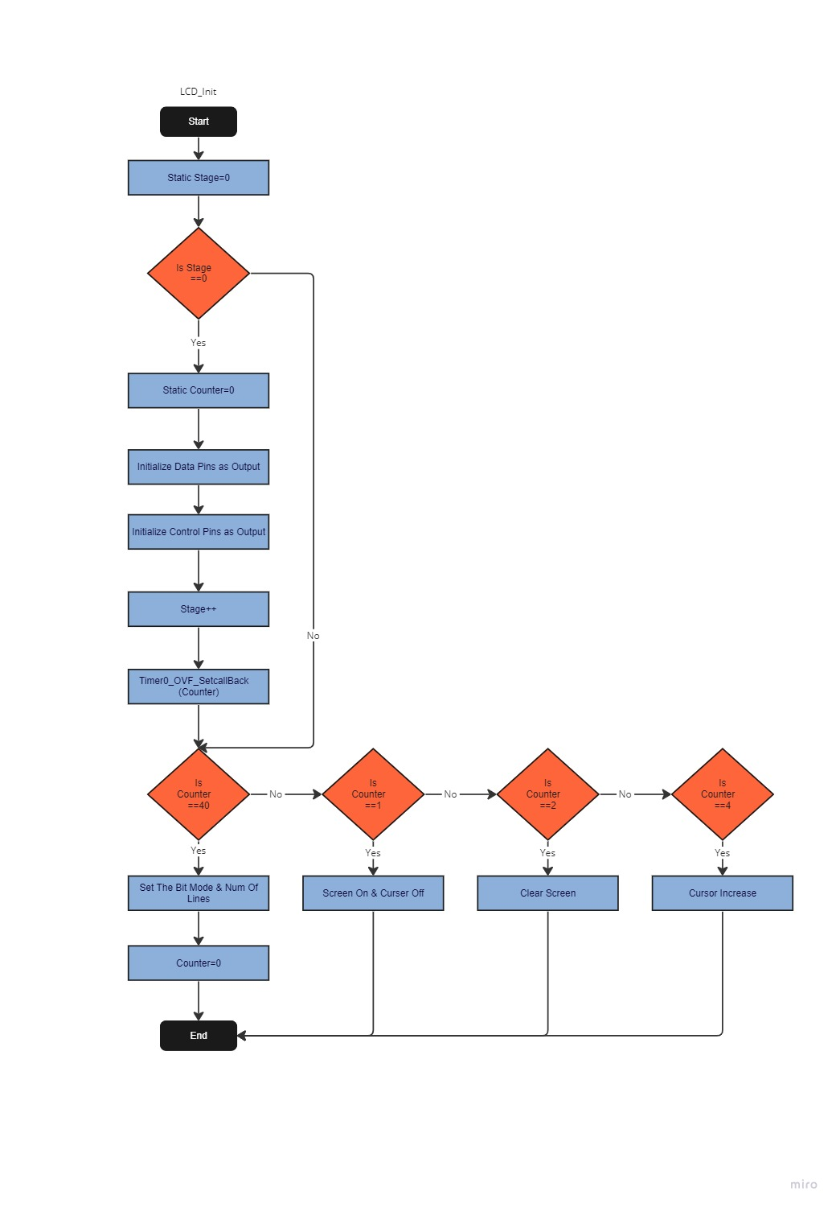
- LCD_Write_Command
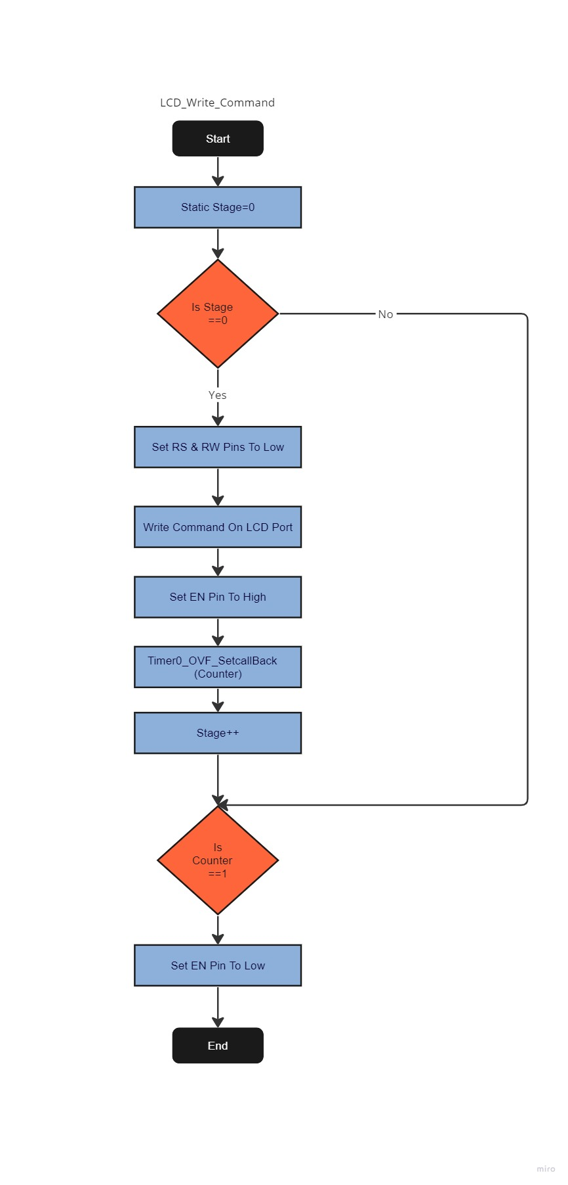
- LCD_Write_Data
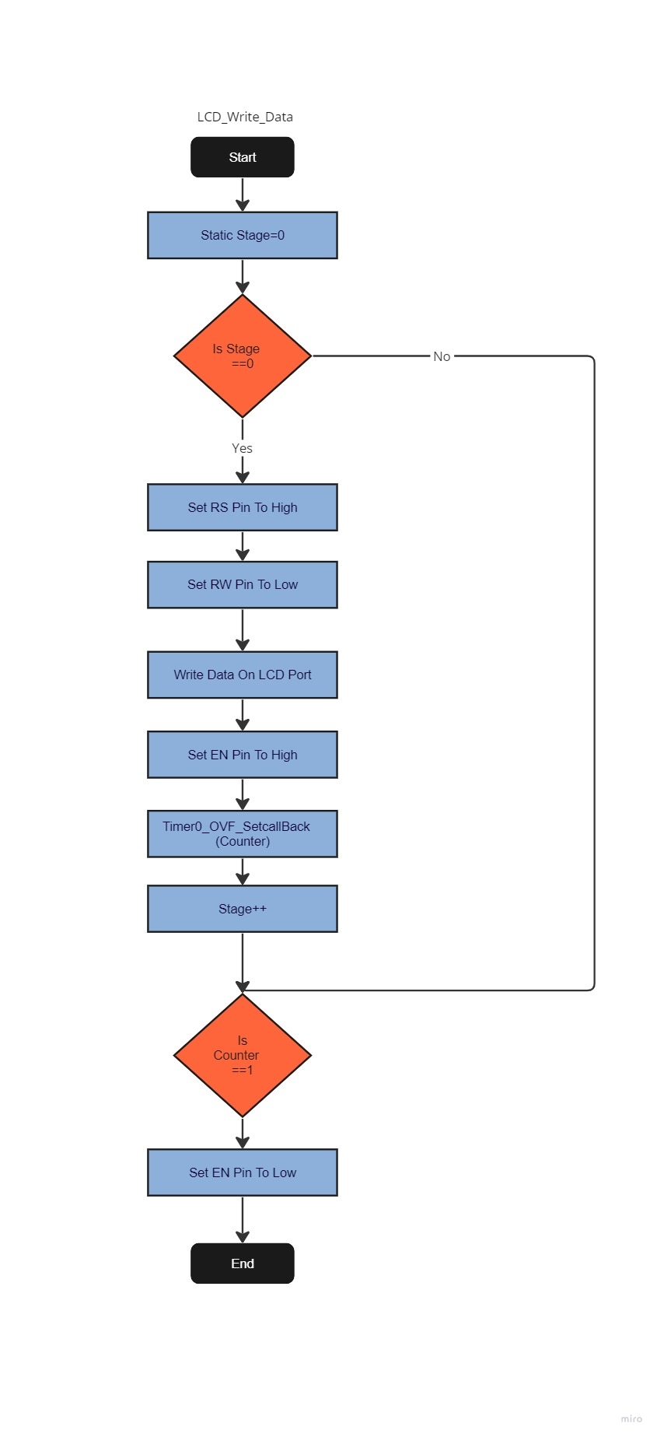

KeyPad With No Blocking Function

Note:-
- Each Over Flow Flag Is Considered as 1_ms For Simplicity
- Both Stage And Counter Variables are Global Static Variables
- Keys_array Is a 4*4 Array Containing The Elements Of The Keypad

- KeyPad_Init
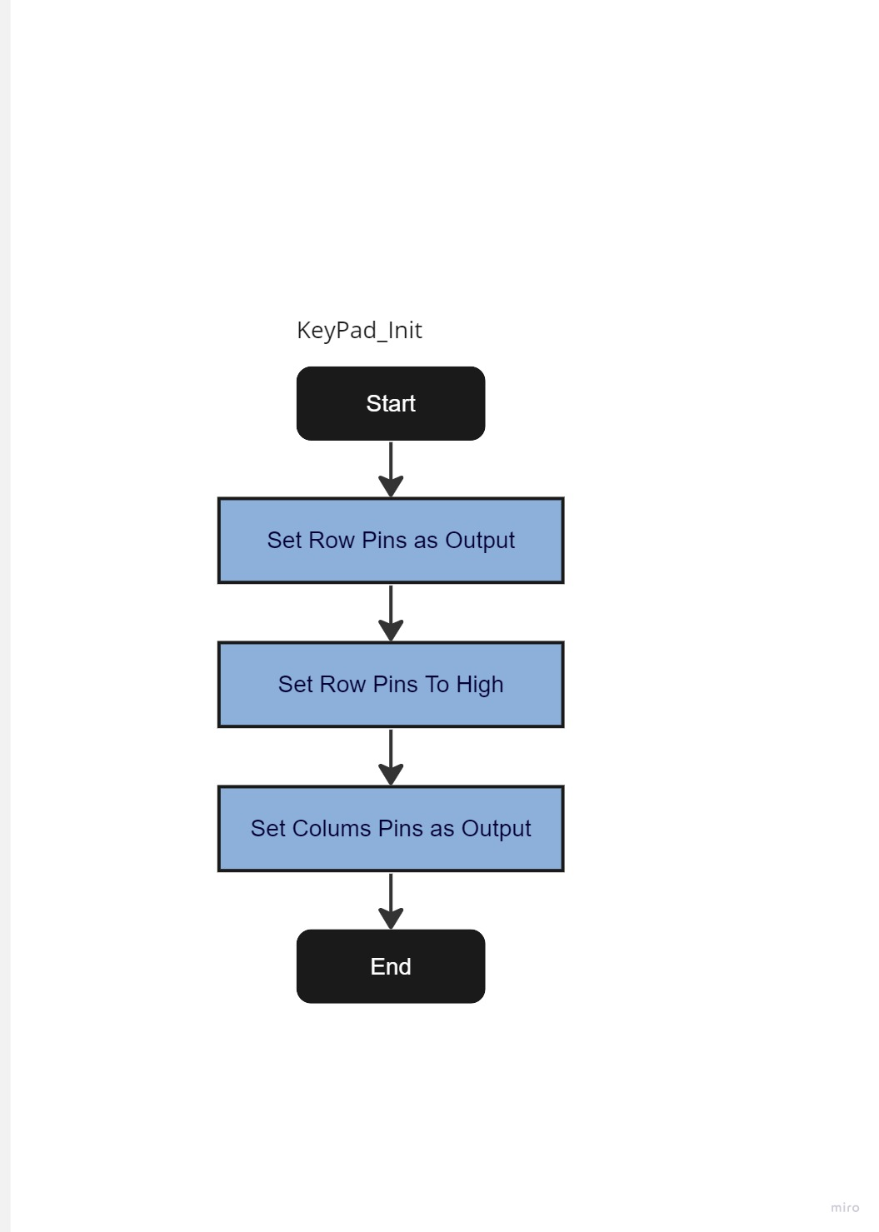
- KeyPad_GetEntery